Technical Document

**Section 1 – Lists of features**

* 1. List of features
  + First-Person
  + Windows Platform
  + Opening scene and Background scene
  + Different levels: Different difficulties and objectives, Progression of using weapons evolves the power of the weapon.
  + Audio and sound effects
  + Demon enemies: Small mob demons, mini bosses and one final boss.
  + Interactive objects
  + Varying weapons
  + Weapon Levels
  + Game world: Characters, Weapons, clouds heaven architecture

**Focus areas:**

The technical focus for our game is **artificial intelligence** since our game will have NPC (teammates) and our enemies having an AI behaviour to attack us.

The design focus is **3D Modelling**, our team want to have impressive visuals of the objects and characters so that the player can feel immersed in the experience of our game.

The art style will have a mixture of realistic features but with cartoonish shaders which is a popular mix for game visuals and is suitable for our target audience preferences.

**Section 2- Choice of Game Engine**

The game engine we will be using is Unity because out of the accessibility for our developers with no budget and the ideal features Unity comes with such as their neat IDE, their interface is easy to learn and eliminates the hassle with applying codes to objects just by dragging them into the object. Great engine that supports making 2D and 3D games possible and.

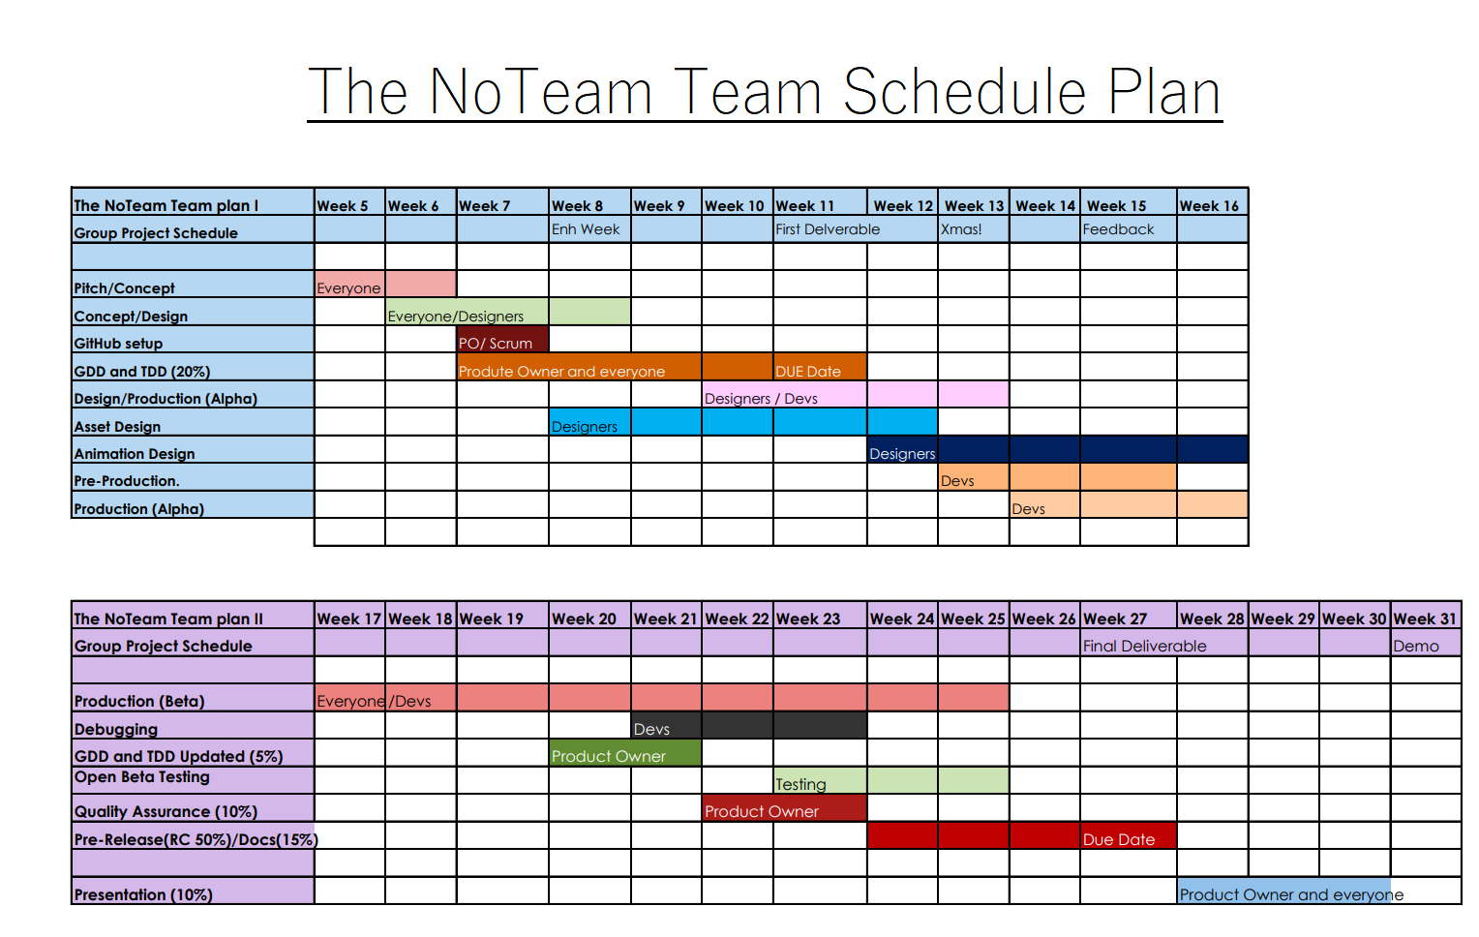**Section 3- Plan Schedule**

**Section 4- Diagrams illustrating software design**

* Layout
* Technology diagram (software used)
* Design diagram (people involved)

[insert diagram]

* Implementation design

4.1 Gameplay Diagram

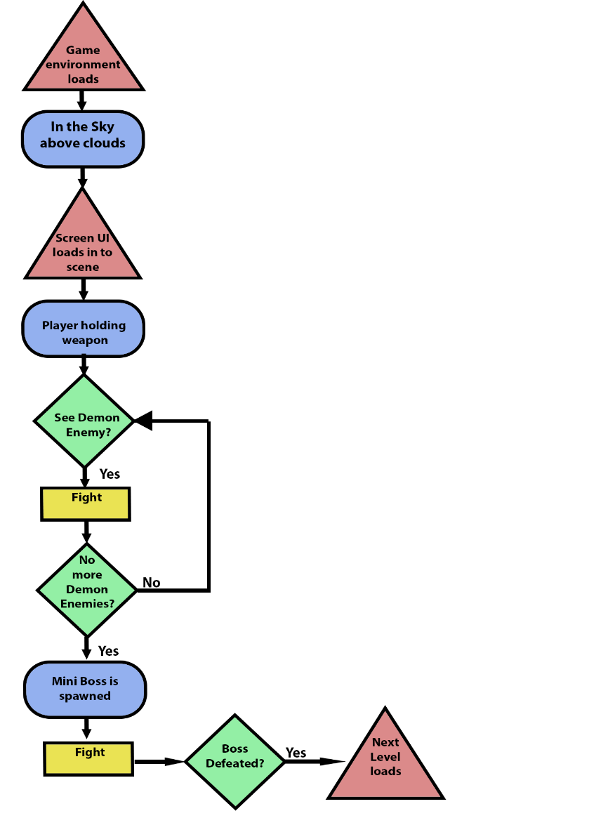

**Section 5 – Art Tools**

* Photoshop (UI assets).
* Maya Autodesk (Character Modelling, rig and animation).
* Unity (Animation tool, Programming and level design with UI).

**Section 6 – 3D Objects, Terrain, & Scene Management**

**6.1 3D Objects:**

Heaven:

* 3D clouds
* Golden throne
* Floating stairway
* Floating building architecture

Weapons:

* Bow and arrow 3 versions according to the level of the weapon.
* Sword 3 versions with the level weapon.
* Pistol with 3 versions for the level of the weapon.
* Axes – for demons

**Section 7- Collision Detection**

* Axes will need collision detection when attacking player.
* Pistol bullets with collision detection to hit enemies.
* Swords will have collision detection to hit enemies with.
* Arrows from bow will have collision detection.

**Section 8- Game Logic, AI**

**What aspects of the game will have Ai?**

* The enemies will have AI to be able to chase us, aim at player and attack the player
* **[Insert AI algorithm}**

**Section 9- Audio & Visual Effects**

* Sound design will consist of royalty free music and own produced dialogue from our team.
* We will be using animation in our UI using Unity’s animation tools.

**Section 10- Delivery Platform & Hardware/Software Requirements**

[technical-design-document-final.pdf (wordpress.com)](https://computergamesmmu.files.wordpress.com/2012/10/technical-design-document-final.pdf)